**ASSET PRICE BUBBLES: IDENTIFICATION, CAUSES AND RESPONSE**

GROUP-1 MEMBERS

1. Pakshal Secretary (Eco) - 190581- [pakshal@iitk.ac.in](mailto:pakshal@iitk.ac.in)**(Group Leader)**
2. Siddharth Kumar Singh (Eco) - 190840 - [sksingh@iitk.ac.in](mailto:sksingh@iitk.ac.in)
3. Tanishq Gupta (BSBE) - 190894 - [tanishqg@iitk.ac.in](mailto:tanishqg@iitk.ac.in)
4. Aman Dixit (BSBE) - 190103 - [amandx@iitk.ac.in](mailto:amandx@iitk.ac.in)
5. Siddharth Kumar Pandey (Eco) - 190839- [siddhkp@iitk.ac.in](mailto:siddhkp@iitk.ac.in)
6. Aman Jain (CE) - 190105 - [amanjain@iitk.ac.in](mailto:amanjain@iitk.ac.in)
7. Abhinav Verma (Eco) - 190032 - [abhive@iitk.ac.in](mailto:abhive@iitk.ac.in)
8. Lochan  Prakash Gupta (CE) - 190459 - [lochanag@iitk.ac.in](mailto:lochanag@iitk.ac.in)
9. Kush Daga (Eco) - 190451 - [kushdaga@iitk.ac.in](mailto:kushdaga@iitk.ac.in)

10. Devesh Goyal (CE) - 190276 - [devesh@iitk.ac.in](mailto:devesh@iitk.ac.in)

**ABSTRACT**

Asset price bubbles have been notorious for causing some of the worst economic crises till date. In this paper we have attempted to devise a method to identify asset price bubbles or economic price bubbles. First we will take a look at some historical price bubbles and what caused them. These will include The Great Depression in the United States in the early 20th century and also the Housing Price bubble in the mid-2000s. Then we will discuss in brief the best monetary policy response and participation response.  We would then  try to devise a relation of asset price bubbles with important macroeconomic factors, such as monetary supply, interest rates, investment, rate of inflation, net export rates,etc, which would indirectly inform us about the relation of these variables in terms of their contribution to severe recessions. This analysis would be done by analyzing the Great Depression on the macroeconomic parameters listed by us. Also, we have attempted to analyze the role of systemic risk contributions of individual financial institutions in price bubble formation.

**INTRODUCTION**

Economic and market activities have been in existence since mankind has been civilized, dating back to ancient times. Starting from the famous Barter system of exchanging goods to current market practices, the markets and economies have come a long way in terms of evolution. There have been many variables affecting markets, which in turn, affect that country’s economy or many a times, the global economy. An asset price bubble is one such phenomenon which has been infamous for causing some of the biggest economic crises to take place till date.

An asset price bubble is formed when assets such as housing, stocks, bonds, real estate, gold, etc. have a dramatic rise in their prices over a short period of time which is not supported by the real value of the product, i.e. their prices rise above their actual fundamental value. In markets, prices do rise and fall above and below the market equilibrium price level respectively depending upon changing trends of supply and demand in the economy, but there is always a tendency of prices going towards equilibrium value as market participants gain experience. But, what makes an asset price bubble different is that the price of assets, after overshooting the equilibrium mark, remains high persistently rather than corrective movement towards equilibrium point. Excessive supply of money and credit flowing in the market make buyers bid up prices higher and higher irrationally. As price increases persistently, there comes a limit beyond which the bubble deflates or bursts, giving rise to economic recession.

Now, coming on the historical front, the first asset price bubble reported was the “ Tulip Mania” price bubble of the Netherlands in 1636-37. The prices of tulip bulbs rose by around 100 percent in the autumn of 1636. Some of the varieties of tulip bulbs considered exotic, saw their prices rising even higher than 100 percent. When these prices reached their peak in the summers of 1637, they fell dramatically, causing devastation in the market. This bubble affected the Dutch market but didn’t have a profound impact on the global market.

The Spanish crisis of 1825, property boom crisis of Germany and Austria of 1873, the Baring crisis of 1890 and stock market crisis of USA of 1907 were some notable crisis due to asset price bubbles before the famous Stock Market Bubble aka The Great Depression of late 1920s busted, causing a severe economic recession. We are going to analyze this crisis in depth in the first section of part 3 of our paper. The US Housing price bubble of 2008 played a noteworthy role in 2008 global economic recession.

Now coming to the objectives of this paper, in the first part, we are going to devise a model for identification of an asset price bubble and apply that model to identify some famous bubbles of  past. Then we would move on to the second part where we would be suggesting some of the best possible responses from the point of view of a monetary policy maker and a market participant in case an asset price bubble is formed. Then, in the third part, we have two sections- the first section would try to access asset price bubbles on macroeconomic parameters. It would be a cause and effect analysis. The second section would deal with the systemic risk contributions of individual financial institutions in price bubble formation.

**LITERATURE REVIEW**

A lot has been written on asset price bubbles by various researchers over the years.  Since price bubbles play a crucial role in causing severe recessions, researchers, across the globe have been trying to analyze asset price bubbles, their impact and role in recessions thoroughly. A paper by Mr. Paul Atkinson, from University of New Hampshire (2012) on asset price bubbles is our first base paper. The concept of asset price bubbles has been explained in a simple and lucid manner in this base paper. Starting from the definition of asset price bubbles, this paper takes us to various historical asset price bubbles, which led to some severe economic crises till date. Then the paper attempts to devise a method to identify asset price bubbles, which is not 100% accurate but can reasonably identify whether an asset price bubble has formed or not by looking at real price index data. Further, the paper suggests possible responses to tackle this scenario.

To go with the base paper, we have chosen an article by Dr. Somer Anderson, Investopedia on how asset price bubbles cause recessions. This article talks about various factors which provide ignition in formation of asset price bubbles ranging from credit in the economy to irrational approach of participants to monetary supply to technological advancements. This article attempts to explain theoretically the relation of these factors with asset price bubbles. But, for the example here, we have chosen two such factors, namely monetary supply and interest rates (to relate with credit), factors that can be quantified.

We have also chosen a research paper on Asset Price Bubbles and Systemic Risk by Markus Brunnermeier, Princeton University, Simon Rother, University of Bonn Isabel Schnabel University of Bonn (2019), they have devised a relationship of asset price bubbles with systemic risk contributions of financial institutions using quantile regression technique with a reasonable accuracy.

**SPECIFICATION OF MODEL (METHODOLOGY)**

**PART - 1**

Our research framework first of all, is concerned with identification of formation of asset price bubbles. If we go by definition, the asset price bubble means a sudden increase in value of an asset or its price, which is an overvaluation of the original value of the asset in question. Also, with persistent increase in prices, a time comes when the market's capacity to accommodate a price bubble is reached, thereafter; increase in prices further would mean that the asset price bubble has burst leading to a sharp fall in prices of that asset.

For identification of an asset price bubble, we have to basically identify abnormal behaviour in price data. For this, we would be using an important measure of central tendency, which is mean and an important measure of distance from a measure of central tendency, which is standard deviation.  We would be considering real price indices in order to have a proper historical comparison of prices of that asset. The methodology is as follows-

1. First of all we would be collecting the dataset of real price indices of the asset under study over a long period of time. This dataset can have price indices of the asset on a monthly basis or on an annual basis depending upon the asset. Since we are collecting real price indices, it would adjust for increase or decrease in prices due to change in cost of living over the years.

2.   Our second step would be to calculate the mean and standard deviation of the real price indices over the whole time period under consideration. By summing up the values of mean of price indices and standard deviation of price indices, we would get an upper bound of price indices, which would be a static reflection of prices over the time period.

3. After getting a static reflection of prices over the whole time period by mean and upper bound of prices, we would go on to plot these things on a graph. Price indices would be plotted on y-axis and year of consideration would be plotted on the x-axis.

4. The price indices for time under consideration would be plotted along with the mean and upper bound price indices line on the graph, Mean and upper bound line would be horizontal (obviously).

5.   This graph, when analyzed, would show sudden increase in prices at the time of price bubble formation and sharp drop afterwards. This can be observed from the graph by comparing the price indices plot with static   lines of mean and upper bound of price indices. This would help us to identify whether an asset price bubble has been formed or not.

As far as this part of analysis is concerned, we expect that our methodology to identify the asset price will have a reasonable accuracy, though not 100%. It would be on the same lines with the author of our base paper. We expect that our results would be in conformity with the base paper we have chosen. Since our methodology uses an important measure of central tendency, which is mean, and distance from measure of central tendency, which is standard deviation, we can surely assert that asset price bubble formation would be easily reflected amongst the static framework we are working with, when we would be analyzing the real price index data graphically.

**PART-2**

The second part of our research framework would be to suggest the best response in order to tackle an asset price bubble and minimize the losses due to these bursts of asset price bubbles. This would be done through viewpoints of a monetary policy maker and a market participant. Monetarists believe in the famous ‘Quantity Theory of Money. They can either take a reactive approach or a proactive approach to deal with asset price bubbles. So, the approach which they should follow as far as controlling the money supply is concerned in order to make sure that these asset price bubbles do not have as devastating an effect on the market as they usually have, would be discussed in detail in our research analysis. Second major player in a market is the market participant himself. Asset price bubbles are formed most of the time due to irrational behaviour of market participants who keep investing in assets resulting in persistent increase in prices of assets. So, once an asset price bubble is identified, what should a market participant do in order to minimize his losses, would be discussed in detail in our research analysis.

In case of a market participant, predicting that the approach would work would have lesser probability compared to the probability of success of approach by monetary policy maker. No approach can assert that it would definitely bail out the economy or an individual out of the crisis, but to some extent only. Here also, we expect that our approaches would be in conformity with the suggestions of base paper to maximum alignment as far as results are concerned.

**PART-3,** **SECTION-1**

In this section, we are going to do a cause and effect analysis of some macroeconomic factors, which define a country’ s economy, with asset price bubbles and in turn, with recessions by doing an in depth graphical analysis of the Great Depression. Two contributing factors which would be accessed would be- interest rates (both real and nominal) and monetary policy of US economy, the role they played in this bubble formation. When we come to effect analysis, we would be analyzing the effect of this bubble, or say recession on these macroeconomic factors of US economy- GDP, Government purchases, consumption and investment. How this crisis affected these pillars of a country’s economy.

**PART-3, SECTION-2**

The second section of part three would involve analysis of the link between the occurrence of asset price bubbles and systemic risk contributions of individual financial institutions.

The prominent measure of systemic risk contribution is ∆CoVaR, given by Adrian and Brunnermeier (2016). It is used to quantify the contribution of a financial institution to the overall level of systemic risk by estimating additional value at risk, which is VaR of the entire financial system associated with the institution experiencing crisis.

*VaR* = Maximum return loss of institution i that would not be exceeded with probability q within a certain time period:

$\operatorname{Pr}\left(X^{i}≤VaR_{q}^{i}\right)=q\%$. (1)

*CoVaR* = *VaR* of system conditional on event *C ($X^{i}$)* of institution i:

$Pr\left(X^{system} | C\left(X^{i}\right)≤CoVaR_{q}^{system|C(X^{i})}\right)=q\%$. (2)

And,

$∆CoVaR_{q}^{system|i}=CoVaR_{q}^{system|X^{i}=VaR_{q}^{i}}-CoVaR_{q}^{system|X^{i}=VaR_{50}^{1}}$ (3)

This is the difference between financial system’s value at risk conditional on institution i, realizing return losses at qth percentile and at 50th percentile.

Higher the value of ∆CoVaR, higher is the systemic risk contribution of the institution i.

We measure ∆CoVaR based on tail dependencies of equity returns, in turn measured using quantile regressions. First, we estimate VaR of institution I as:-

${\hat{VaR}}_{q,t}^{i}={\hat{X}}_{t}^{i}={\hat{α}}_{q}^{i}+{\hat{γ}}_{q}^{i}M_{t-1}$ (4)

where,

$M_{t-1}$ = A vector of control variables consisting of general risk factors.

${\hat{X}}_{t}^{i}=$ Return losses on equity of institution i

We have to apply stress of q = 98% in all regressions.

We estimate the relationship between institute specific losses and system losses by:

${\hat{X}}_{q,t}^{system|i}={\hat{α}}_{q}^{system|i}+{\hat{γ}}_{q}^{system|i}M_{t-1}+{\hat{β}}_{q}^{system|i}X_{t}^{i}$. (5)

By using the previous regressions, we would calculate conditional value at risk by:

${CoVaR}_{q,t}^{i}={\hat{α}}_{q}^{system|i}+{\hat{γ}}_{q}^{system|i}M_{t-1}+{\hat{β}}_{q}^{system|i}{\hat{VaR}}_{q,t}^{i}$. (6)

Using the equation number 3, we can now calculate time series of ∆CoVaR as

$∆CoVaR_{q,t}^{i}={\hat{β}}_{q}^{system|i}({\hat{VaR}}_{q,t}^{i}-{\hat{VaR}}_{50,t}^{i})$. (7)

This approach gives us the monthly estimates of ∆CoVaR of required no. of institutions. We can take its mean to have a better picture of the estimate.

Finally, in order to establish relationship between asset price bubble formation and systemic risk of individual financial institutions, we regress systemic risk $∆CoVaR_{q,t}^{i}$ of institution I at time t on:-

1. bank fixed effects ($α_{i}$),
2. t bubble indicators for the booms and busts of stock market and real estate bubbles (${Bubble}_{c,t}$) in country c at time t, the lagged bank-level variables size, loan growth, leverage, and maturity mismatch ( $B_{i,t-1}$), the interaction terms with bubble indicators, and lagged country-specific macroeconomic control variables ($C_{c,t-1}$):

${∆CoVaR}_{i,t}=α_{i}+β∙{Bubble}_{c,t}+γ∙B_{i,t-1}+δ∙{Bubble}_{c,t}∙B_{i,t-1}+λ∙C_{c,t-1}+u_{i,t}$.

Here, the bank fixed effects would have control for important balance sheet characteristics, namely bank size, loan growth, leverage, and maturity mismatch and macroeconomic variables would be data of CPI or GDP deflator.

All the relevant and required data would be collected and worked upon to find relationship between asset price bubble formation and systemic risk contributions of individual financial institutions.

**APPLICATION OF THE MODEL (BODY)**

**PART 1**

As mentioned in the previous section, part 1 of our analysis would use measure of central tendency, i.e. mean and distance from mean, i.e. standard deviation to get a static framework of data and then analyze the price index values graphically to identify bubble formation. Here, we are identifying the following bubbles-

1. The Dutch Tulip Mania of 1636-37
2. US Housing price bubble of mid 2000s
3. Japan Real Estate bubble of late 80s and early 90s.

**DUTCH TULIP MANIA**

The first ever asset price bubble reported in the history was the “Tulip Mania” price bubble of the Netherlands in 1636-37. The prices of tulip bulbs rose by around 100 percent in the autumn of 1636. When these prices reached their peak in the summers of 1637, they fell dramatically, causing devastation in Dutch market. In the analysis of this crisis, the mean of price index comes out to be 110 with standard deviation 42.4007 and mean plus standard deviation value is 152.40072.

**DATASET**

|  |  |
| --- | --- |
| **TIMELINE** | **TULIP BULB PRICE INDEX** |
| 12 November 1637 | 10 |
| 25 November 1637 | 100 |
| 1 December 1637 | 110 |
| 12 December 1636 | 150 |
| 3 February 1637 | 180 |
| 5 February 1637 | 170 |
| 9 February 1637 | 150 |
| 1 May 1637 | 10 |

**PLOT**

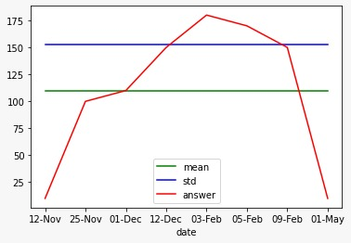

As we do the graphical analysis of the limited data available for this bubble, we find that prices of tulip bulbs start rising after 12th November 1636, and the rise observed was dramatic to say, at least. It crossed the mean line on 1st December and upper bound line on 12th December. But still, we are not sure that it is a bubble, it may be due to high inflation in market. But, as we observe from the graph, after reaching its peak on 3rd February 1637, t falls dramatically and as we approach May 1637 the curve has fallen way below the mean level, indicating a bubble burst. Hence, we identify that this was indeed an asset price bubble.

**US HOUSING PRICE BUBBLE**

The US Housing price bubble was one of the major contributors to the 2008 global economic crisis among other factors. The housing prices rose sharply to become overvalued and then fell dramatically resulting in a severe economic crisis. The graph representing price index corresponding to year in consideration is drawn from dataset. We calculate the mean which came out to be 186.5838 and standard deviation came out to be 23.907. The upper bound of mean+ standard deviation is thus equal to 210.4908.

**DATASET**

|  |  |
| --- | --- |
| **YEAR** | **PRICE INDEX** |
| 2000 | 137.20 |
| 2001 | 146.14 |
| 2002 | 156.72 |
| 2003 | 172.43 |
| 2004 | 185.73 |
| 2005 | 205.55 |
| 2006 | 220.31 |
| 2007 | 225.41 |
| 2008 | 211.05 |
| 2009 | 190.85 |
| 2010 | 183.96 |
| 2011 | 178.16 |
| 2012 | 185.29 |
| 2013 | 200.42 |
| 2014 | 210.17 |

**PLOT**

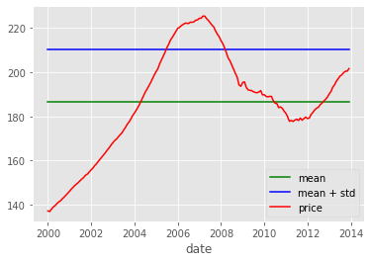

As we can observe from the graph, as cost of living changes over the years, price index changes. As it crosses the upper bound line in 2005 after that, we can see that it persistently increases, but still, we can’t say here with surety that bubble is forming up, as other factors may be contributing to price increase. But conclusive evidence is seen around 2008, when price index falls sharply and even falls below mean line in 2010. This is burst of asset price bubble in housing sector where housing prices fall drastically after building up for a while and this is the famous 2008 US Housing Price Bubble burst we all know. Hence, formation of asset price bubble is seen to start around 2005, which eventually bursts in 2008, continuing to affect the price of asset till 2010.

**JAPAN REAL ESTATE BUBBLE**

The Japanese real estate price bubble was observed in late 80s and early 90s, with its burst reportedly happening around the year 1992. The real estate prices started rising became overvalued and eventually, when the limit was reached the bubble burst, leaving the Japanese economy in severe recession. Irrational behaviour of property buyers is touted as the major reason for this bubble. In the graphical analysis which we have done on real estate price indices, the mean of price indices is 140.4090909 and standard deviation being 129.7248587, the mean plus standard deviation being 270.1339496.

**DATASET**

|  |  |
| --- | --- |
| **YEAR** | **PRICE INDEX** |
| 1971 | 50 |
| 1973  1975 | 70  60 |
| 1977 | 70 |
| 1979 | 75 |
| 1981 | 80 |
| 1983 | 100 |
| 1985 | 110 |
| 1987 | 200 |
| 1989 | 220 |
| 1991 | 500 |
| 1993 | 530 |
| 1995 | 200 |
| 1997 | 130 |
| 1999 | 110 |
| 2001 | 90 |
| 2003 | 85 |
| 2005 | 80 |
| 2007 | 85 |
| 2009 | 82 |
| 2011 | 80 |
| 2013 | 82 |
| 2015 | 81 |

**PLOT**

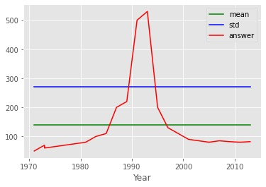

As we analyze the graph, we see that price index value starts rising slightly from 1971, but this slight increase is due to change in the cost of living. But around 1985, the curve shows a tendency to cross the mean line and eventually crosses it in 1986. It crossed the upper bound line in 1989 and with dramatic increase, even crosses the 500 mark in 1992, reaching its peak around 1993-94. Again, till now, it may be due to inflation and further analysis is required to confirm whether it is a price bubble or not. But as we can see after 1993, the price index falls dramatically, with the curve going below even the mean line in 1998. This fall confirm that indeed this is a price bubble.

**PART-2**

In this section , we are going to suggest the best possible responses after an asset price bubble has been formed from the viewpoints of-

1. Monetary policy maker

2. Market participant

**MONETARY POLICY RESPONSE**

While dealing with asset price bubbles, Monetary policy has two schools of thought:-

  1). Proactive approach

2). Reactive approach

**Cecchetti, Genberg and Wadhwani‘s take on monetary policy response**

Let’s see what Cecchetti, Genberg and Wadhwani suggest regarding the best monetary policy response in case a price bubble is detected. They assert that the aim of monetary policy is to reduce asset price bubbles because this will minimize the boom-burst cycle and decrease the distortion that asset price bubbles have on both consumption and investment. Monetary policy officials should react to asset price bubbles with changes in interest rates under certain situations. The probability of an asset price bubble form can be decreased to a great extent by declaring publicly that monetary authorities will lean against asset price bubbles. The proactive policy will be most effective when the source of shock is financial in nature and not real.

**Believes and propositions of Michael Bordo and Olivier Jeanne on monetary policy response**

Michael Bordo and Olivier Jeanne assert that Taylor Rule is the right way to make decisions, urging a need for more discretionary decision making based on arising circumstances. Large price reversals impose large adverse effects on the economy. The decision to use proactive monetary policy should be based on the balance sheet risk to asset price movement. Monetary authorities should sometimes restrict monetary policy above and beyond what it takes to reach their inflation targets.( Analysed from The great depression and Japanese asset price bubble of the late 1980s).There should be a balance between current output and the probability of a credit crunch. If the current output loss is larger, the proactive policy isn't optimal, and it's optimal if current output loss is smaller.

**Reasons for rejecting proactive monetary policy:**

1. They depend a lot on predicting the impacts of unpredictable events.
2. Proactively targeting asset price bubbles could lead to pricking the bubble.
3. It lacks the transparency of a Taylor Rule reactive system.( Reactive policy set its goals based on a clear target for inflation).

**Incidents when proactive approach of targeting asset prices has led to the pricking of bubble:-**

1. The great depression
2. Japan's case (1980s and 90s)

**MARKET PARTICIPANT APPROACH**

It's very difficult to determine the best approach for each market participant when a bubble is forming.

**Prediction of the efficient market theory:** On realising that an asset is above its fundamental value, a rational participant will work against the mispricing until it returns to its fundamental value.

 But this is not what happens when a bubble is formed.

**Risky approach -**

1. Many participants will make attempts to ride the bubble and time the market so they sell at the peak.
2. Shorting the market upon identification of a bubble can be very costly in short run in both performance and fund outflows, because the bubble may persist for some time.

**Safest approach :** Sell the stocks by identification and moving to safer asset classes that are not highly correlated with equity prices.

**It's advantages:**

1. Capital preserved.
2. Greater Buying opportunity after crash.

**PART-3, SECTION-1**

In the late 1920s and early 1930s, a terrible recession started in USA like a forest fire, spread all across to Europe and became a global catastrophe. It was the famous stock market bubble aka the Great Depression. It was not only an economic catastrophe but a social and political catastrophe as well. People lost their jobs, unemployment rates touched an all time high, food scarcity was at its peak and people lost their shelters. People had to be content with meager part-time jobs, which were also farfetched. We are going to do a cause and effect analysis of some macroeconomic factors in the context of this recession.

**CAUSE ANALYSIS (CONTRIBUTING FACTORS)**

Two of the major contributing macroeconomic factors, which stood out among others were-

1. Money supply in the US economy before the depression

and also during it.

1. The nominal and real interest rates that were prevailing in the US economy at the time of the depression.

**MONETARY SUPPLY ANALYSIS**

We have plotted the money supply data of the period of depression taking into consideration both the definitions of money supply- M-1 and M-2. M-1 money supply includes the currency in circulation in the economy plus demand deposits, while the M-2 definition includes M-1 plus savings account deposits. The analysis in this section has data starting from 1925, just before depression and going through to 1933, the year when the depression ended.

**DATASETS**

**M-1 MONEY SUPPLY**

|  |  |
| --- | --- |
| **YEAR** | **MONEY SUPPLY ( IN BILLION DOLLARS)** |
| 1925 | 27.4 |
| 1926 | 27.8 |
| 1927 | 27.9 |
| 1928 | 28.4 |
| 1929 | 26.6 |
| 1930 | 25.8 |
| 1931 | 24.1 |
| 1932 | 21.1 |
| 1933 | 19.9 |

**M-2 MONEY SUPPLY**

|  |  |
| --- | --- |
| **YEAR** | **MONEY SUPPLY (IN BILLION DOLLARS)** |
| 1925 | 42.2 |
| 1926 | 43.7 |
| 1927 | 44.7 |
| 1928 | 46.4 |
| 1929 | 46.8 |
| 1930 | 45.7 |
| 1931 | 36.1 |
| 1932 | 32.2 |
| 1933 | 31.1 |

**PLOTS**

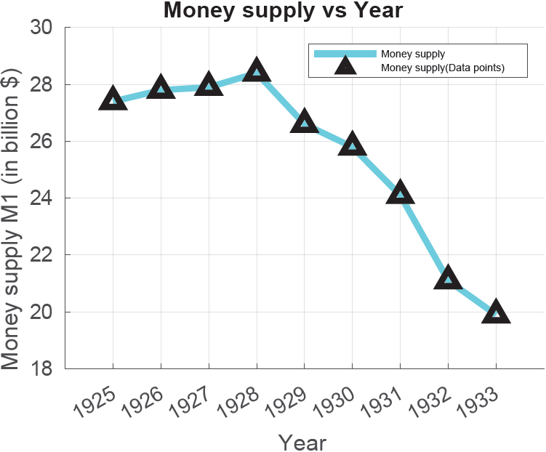

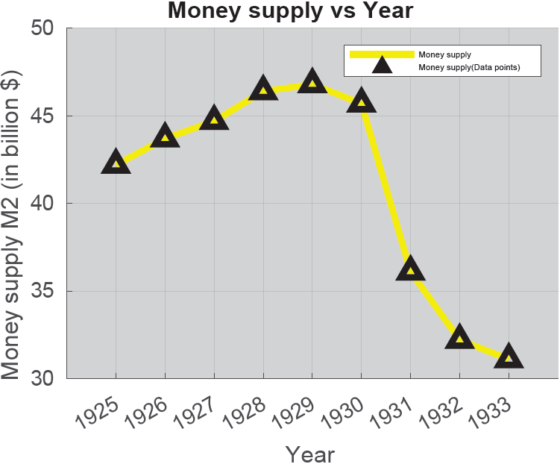

As seen from both the graphs, both M-1 and M-2 money supply increased from 1925 till the time of start of the depression. It meant that central bank had sensed shortage of money in supply due to various reasons ( foreign credits included) and , in pursuit of revamping the economy, had increased the money supply, going with the principle of quantity theory of money. But, this move backfired and the real value of US Dollar declined, leading to stock market crash, eventually leading to the Great Depression.

**INTEREST RATE ANALYSIS**

Not only economists, but also historians, who covered this crisis assert that easy credit from USA to the newly formed Weimer republic (present day Germany) in order to come out of crisis caused by First World War, was the major fuel to ignite this crisis. We have graphs of both nominal interest rate and real interest rate (which has been adjusted for inflation) which would give us a clear picture.

**DATASETS**

**NOMINAL INTEREST RATE DATA**

|  |  |
| --- | --- |
| **YEAR** | **RATE OF INTEREST (IN %)** |
| 1929 | 5.85 |
| 1930 | 3.59 |
| 1931 | 2.64 |
| 1932 | 2.73 |
| 1933 | 1.73 |

**REAL INTEREST RATE DATA**

|  |  |
| --- | --- |
| **YEAR** | **RATE OF INTEREST (IN %)** |
| 1929 | 7.00 |
| 1930 | 7.87 |
| 1931 | 14.04 |
| 1932 | 15.92 |
| 1933 | 4.54 |

**PLOTS**

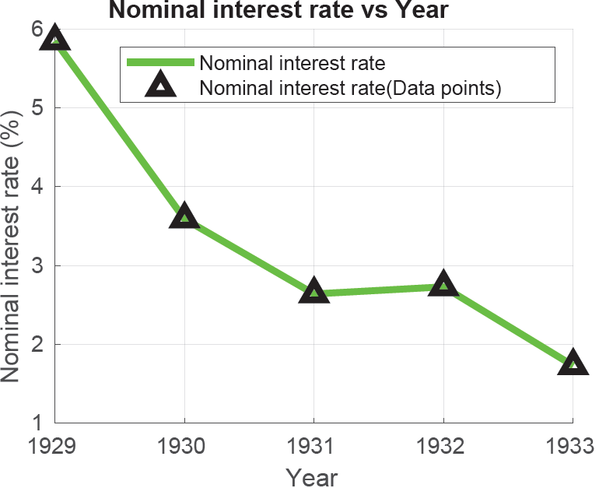

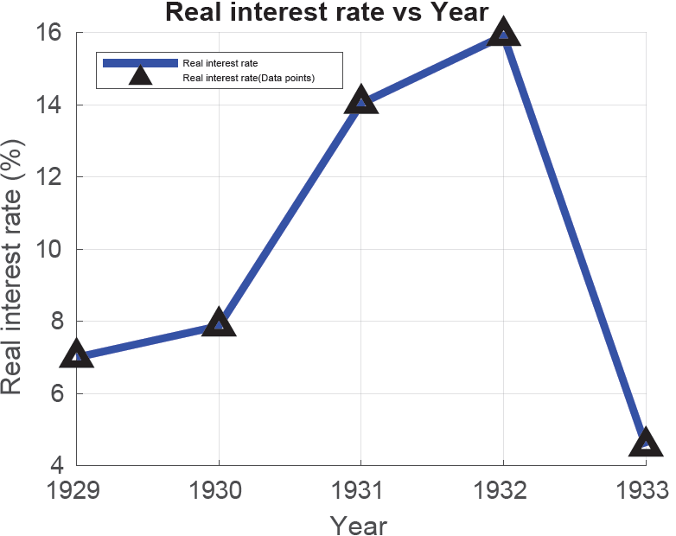

The nominal interest rates, as shown in the graph, continuously falls, rising slightly after 1932 ( that too a nominal rise), is due to falling investment as private players were not willing to borrow but doesn’t give us a clear picture of credit scenario. But the real interest rate, which adjusts for contemporary deflation, is low in 1929, indicating that at the start of crisis; loans were given too easily, resulting in shortage of money available with the government to use in fiscal policies. It rose thereafter, due to banks trying to revamp the economy by avoiding credits.

**EFFECT ANALYSIS**

After doing a comprehensive analysis of contributing factors, we are now going to analyze the effect of this recession on some of the macroeconomic parameters of US economy. The parameters included are-

1. US GDP
2. Government purchases.
3. Investment
4. Consumption.

**USA GDP ANALYSIS**

**DATASET**

|  |  |
| --- | --- |
| **YEAR** | **US GDP ( IN BILLION DOLLARS)** |
| 1929 | 790.9 |
| 1930 | 719.7 |
| 1931 | 674.0 |
| 1932 | 584.3 |
| 1933 | 577.3 |

**PLOT**

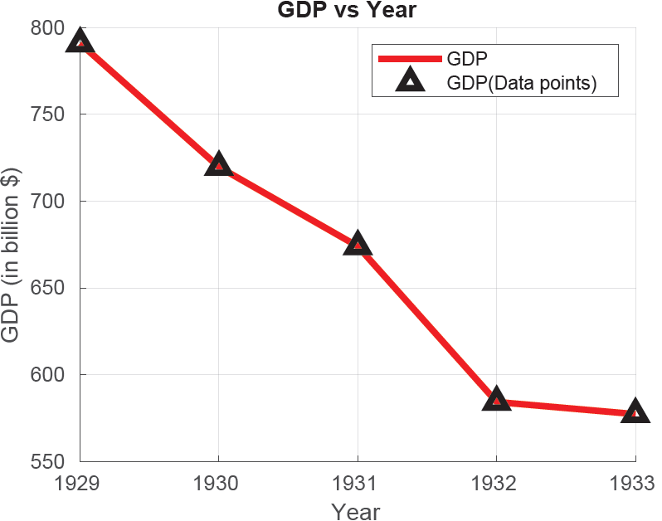

The output of an economy is measured by its Gross Domestic Product and the graph shows the decline in production from its high point in 1929 to its low point in 1933 as the depression progressed. Since unemployment was at its peak, far away from the full employment point, the production in economy was bound to be declining as maximum of workforce was not working due to contemporary deflation and simple macroeconomics suggests that lower workforce employed, low prices leads to lower sale of commodities in market, eventually leading to lower levels of production.

**GOVERNMENT PURCHASE ANALYSIS**

**DATASET**

|  |  |
| --- | --- |
| **YEAR** | **US GOVERNMENT PURCHASE (IN BILLION DOLLARS)** |
| 1929 | 105.4 |
| 1930 | 116.2 |
| 1931 | 121.2 |
| 1932 | 117.1 |
| 1933 | 112.8 |

**PLOT**

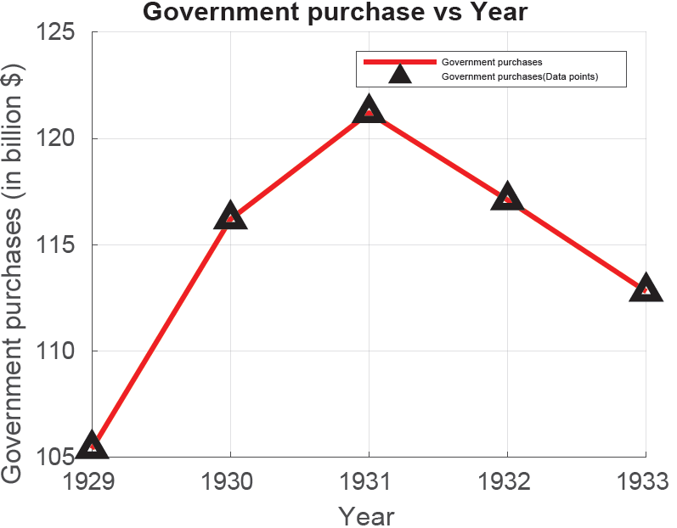

Government controls fiscal policy of a nation and can control its purchases and expenditure according to prevailing situation in the economy. As we can see from the graph, as the depression started in 1929, there was a problem of prevailing deflation in the economy with production going down; this prompted the US government to increase the purchases in order to increase the supply of goods in the economy. This increased till 1931, after that, the government, due to scarcity of goods created by this depression, had to decrease its purchases, worsening the situation even further.

**PRIVATE INVESTMENT ANALYSIS**

**DATASET**

|  |  |
| --- | --- |
| **YEAR** | **US PRIVATE INVESTMENT ( IN BILLION DOLLARS)** |
| 1929 | 92.4 |
| 1930 | 59.8 |
| 1931 | 37.6 |
| 1932 | 9.9 |
| 1933 | 16.4 |

**PLOT**

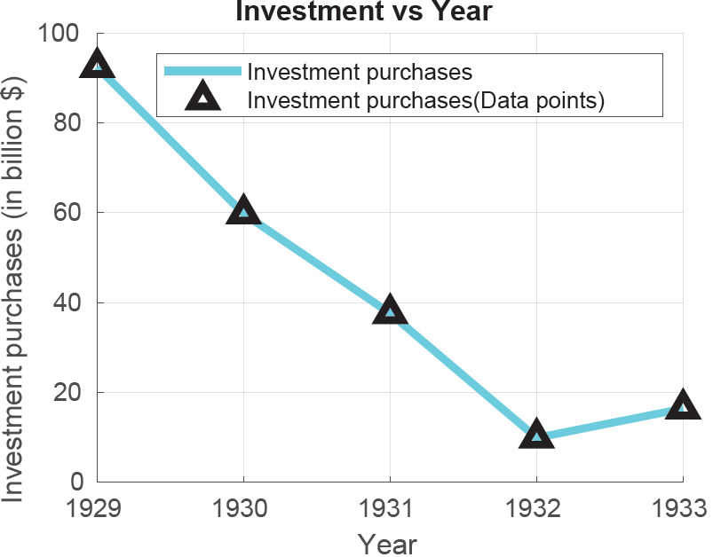

Macroeconomic algebraic models suggest that as government expenditures increase, private investment chokes because the money kept in banks is used for the time being by the government in order to finance its purchases, making lesser money available for private investment. The same thing is reflected by the graph which shows a decrease in investment corresponding to increase in government purchases. It slightly increased after 1932 after hitting a trough because by that time, government controlled its expenditure but due to deflation, significant increase is not observed.

**CONSUMPTION ANALYSIS**

**DATASET**

|  |  |
| --- | --- |
| **YEAR** | **US CONSUMPTION( IN BILLION DOLLARS)** |
| 1929 | 593.9 |
| 1930 | 562.1 |
| 1931 | 544.9 |
| 1932 | 496.1 |
| 1933 | 484.8 |

**PLOT**

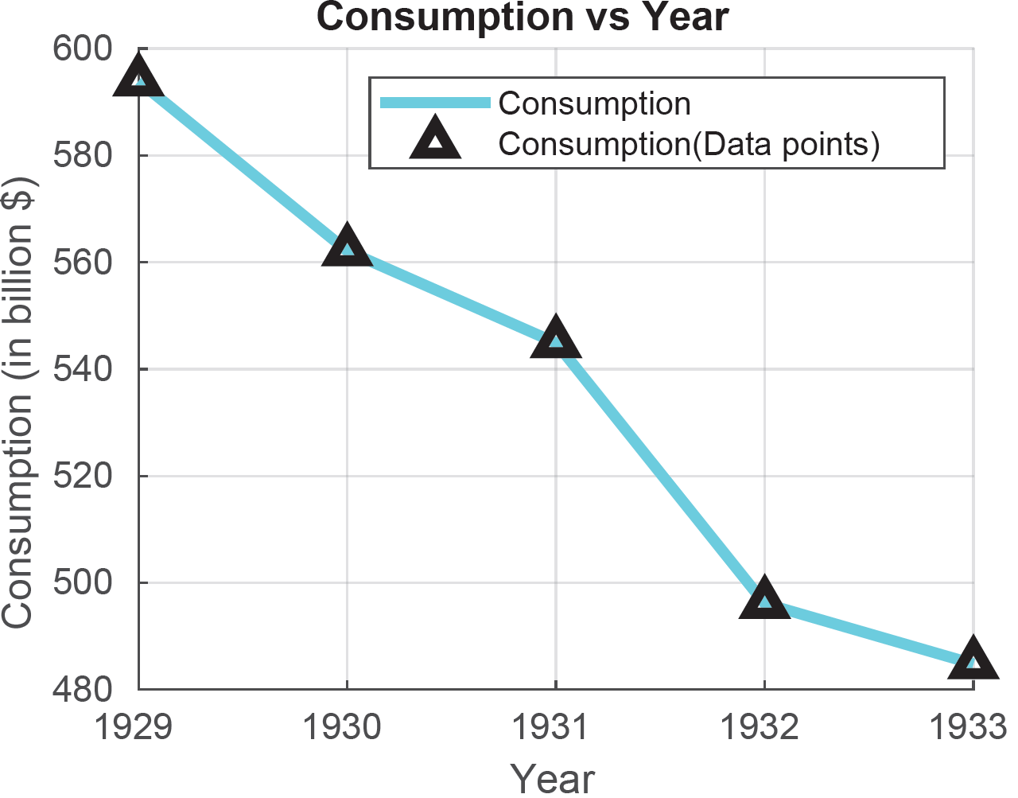

As the economic crisis continued, the level of consumption of goods showed a sharp decline, which was as expected. The GDP was declining, along with private investment (which showed only a little resurgence, that too at the end of depression), eventually resulting in consumption levels hitting a record low point. People had no money to consume; unemployment was at its peak, with the value of US Dollar declining at a brisk rate, resulting in a severe under- consumption.

**PART-3, SECTION- 2**

The last part of the last section of our framework would deal with link between asset price bubbles and systemic risk at bank level. For this purpose, as specified in the model specification section, we would be using the ∆CoVaR measure, devised by Adrian and Brunnermeier in 2016. This measure assumes banks to be risk inducers and a reasonable measure to quantify systemic risk, hence allowing us to take inference about its relation with asset price bubbles. For our analysis, we have chosen two financial institutions, one each from Japan and North America. The year wise computed systemic risk values from North America are reflected in the following table,

|  |  |
| --- | --- |
| **YEAR** | **∆CoVaR** |
| 1985 | 2.21 |
| 1986 | 2.46 |
| 1987 | 3.50 |
| 1988 | 3.96 |
| 1989 | 3.86 |
| 1990 | 1.76 |
| 1991 | 1.96 |
| 1992 | 1.94 |
| 1993 | 1.85 |
| 1994 | 1.90 |
| 1995 | 1.70 |
| 1996 | 1.82 |
| 1997 | 2.00 |
| 1998 | 2.10 |
| 1999 | 1.86 |
| 2000 | 2.00 |
| 2001 | 1.78 |
| 2002 | 2.05 |
| 2003 | 1.90 |
| 2004 | 1.75 |
| 2005 | 1.60 |
| 2006 | 1.62 |
| 2007 | 2.43 |
| 2008 | 4.23 |
| 2009 | 3.25 |
| 2010 | 1.66 |
| 2011 | 1.94 |
| 2012 | 1.96 |
| 2013 | 2.15 |
| 2014 | 1.82 |
| 2015 | 1.96 |
| 2016 | 2.15 |

**PLOT**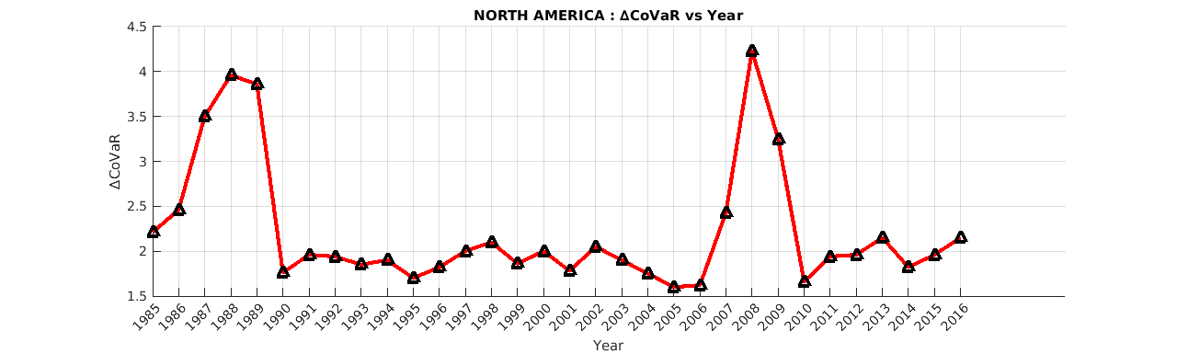

Just like what we expected in our hypothesis, the systemic risk contribution is seen to have a positive direct relationship with episodes of price bubble formation and a negative indirect relationship with episodes of burst of the bubble. As we clearly observe the data or the graph, we can see that it reaches its peak (quite a sharp one) in just before 2008, or in early months of 2008 and has a sharp decline thereafter, this time period resonates with the time period of the US Housing price bubble, and in mid-2008, it busted, which we analyzed in the first part. So, systemic risk follows the price bubble here.

For Japan, the year wise computed values of systemic risk are

|  |  |
| --- | --- |
| **YEAR** | **∆CoVaR** |
| 1987 | 3.85 |
| 1988 | 4.00 |
| 1989 | 6.22 |
| 1990 | 6.00 |
| 1991 | 5.85 |
| 1992 | 4.20 |
| 1993 | 3.46 |
| 1994 | 2.70 |
| 1995 | 3.90 |
| 1996 | 3.50 |
| 1997 | 4.10 |
| 1998 | 3.65 |
| 1999 | 4.02 |
| 2000 | 4.00 |
| 2001 | 2.98 |
| 2002 | 2.84 |
| 2003 | 4.21 |
| 2004 | 3.15 |
| 2005 | 3.40 |
| 2006 | 3.45 |
| 2007 | 4.36 |
| 2008 | 7.64 |
| 2009 | 3.90 |
| 2010 | 3.95 |
| 2011 | 3.20 |
| 2012 | 2.96 |
| 2013 | 5.62 |
| 2014 | 4.10 |
| 2015 | 3.90 |
| 2016 | 5.46 |
| 2017 | 4.22 |

**PLOT**

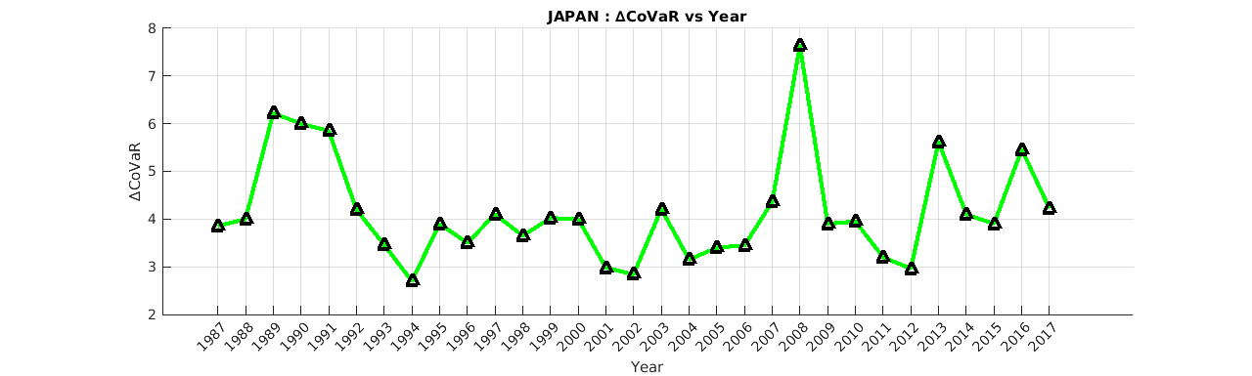

Just like what we observed in the case of North America and also in line with our expectations, the value of systemic risk remains high at the time of asset price bubble formation. In the first section, we identified the Japanese Real Estate price bubble, which started to build up around late 80s and busted in early 90s. The same thing is being reflected by the trends in systemic risk; it peaks so high during the bubble formation period that it touches 4.00 mark and then drastically falls at the time when the bubble bursts in early 90s. This further strengthens our hypothesis of having a direct positive relation of ∆CoVaRwith the episodes of bubble formation and a negative indirect relation with episodes of bubble burst.

**RESULTS AND CONCLUSION**

Most of the inferences that were to be drawn from the available data had been drawn an presented in the data application section only. Here, in this section, we are going to summarise our findings from different sections.

1. The first part is a straightforward graphical analysis, which is very accurate in price bubble identification.
2. In the second part, we conclude that the best responses from the respective viewpoints are-
3. Monetary policy maker- Reactive policy is the best policy rather than the proactive one.
4. Market participant- A participant should sell the asset the moment he realizes that asset prices have a tendency of overvaluation.
5. In the causal analysis, we conclude that real interest rates have a negative indirect relationship with the probability of price bubble formation and money supply has a positive direct relationship with probability of price bubble formation.
6. In the effect analysis, we conclude that a nations’ s GDP and consumption are negatively affected by asset price bubble while private investment depends upon the corresponding government purchases, both having an indirect relationship with each other.
7. In the last section, we conclude that higher the value of ∆CoVaR, higher is the systemic risk contribution of that financial institution, which helps us to identify its relation with asset price bubbles. We observed from data analysis that systemic risk is positively and directly related to the bubble formation episode, that is, when price bubble starts forming, systemic risk is high and falls drastically upon the burst of price bubble, indicating a negative and indirect relationship of asset price bubble with bubble burst episodes.

Overall, over work is an intensive one on asset price bubbles, right from identifying them to suggesting best responses from two main viewpoints to go deeper into cause and effect analysis to linking systemic risk with it. All in all, we have tried to tried to look at price bubble from 4 different perspectives.

**REFERENCES**

1. Paul Atkinson, Asset Price Bubble Identification and Response, University of New Hampshire, published in Economic Commons, 2012. (BASE PAPER)

[https://scholars.unh.edu/cgi/viewcontent.cgi?article=1001&context=honors#:~:text=This%20paper%20investigates%20the%20existence,both%20rational%20and%20irrational%20participants](https://scholars.unh.edu/cgi/viewcontent.cgi?article=1001&context=honors)

1. Article by Investopedia, How Do Asset Price Bubbles Cause Recessions? (2020)

<https://www.investopedia.com/articles/investing/082515/how-do-asset-bubbles-cause-recessions.asp>

1. Brunnermeier, Rother and Schnabel, Asset Price Bubbles and Systemic Risk, published in Journal of Economic Perspectives, 2008.

<https://scholar.princeton.edu/markus/publications/asset-price-bubbles-and-systemic-risk>

,